The experiential travel guide

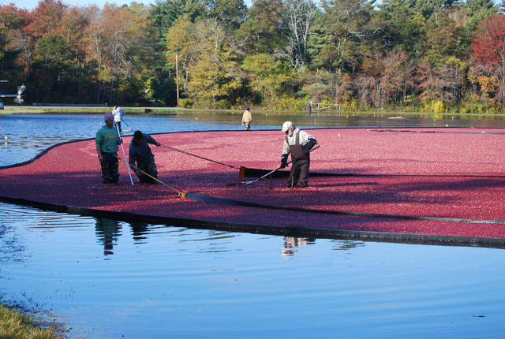
Lara Takenaga
AFAR
Aug 28, 2013

New England Cranberry Harvest
Every October in New England, farmers head to their bogs for the cranberry harvest. At the 112-acre Mayflower Cranberries farm in Plympton, Massachusetts (mayflowercranberries.com), you can join a Be the Grower experience and help gather the tart fruit. Strapped into waterproof overalls, you’ll use rake-like tools to corral and collect the cranberries. As you wade through the crimson oasis, take in the fall colors of the oak and maple trees and watch for wild turkeys and red-tailed hawks. Afterward, pick up some jam from the Mayflower farm stand for a taste of what the berries can become.
For more cranberry bogs, visit Cape Cod and book a room at the Platinum Pebble Inn. 186 Belmont Rd., West Harwich, (508) 432-7766, platinumpebble.com. This appeared in the October 2013 issue. Photo by Massachusetts Energy and Environmental Affairs/Flickr

