A TANK AWAY

Add spring to your step in Harwich
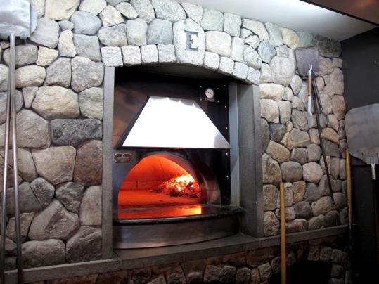
The oven at Ember Coal Fired Pizza & Wings.
By Ellen Albanese
Boston Globe correspondent / April 30, 2013
Coastal Living magazine won’t reveal the winner of its “Happiest Seaside Town 2013” contest until May 10. But it could be Harwich Port, one of seven villages in this Cape Cod town, and one of 10 finalists in the magazine’s survey. What makes Harwich happy? Beaches, restaurants, nature trails, fishing — they’re all here. The town’s historical heart is Harwich Center, a picture-postcard New England landscape with a park, church spire, and old, well-maintained houses. But the action is in the Port, with restaurants and shops, outdoor entertainment in summer, and side streets leading straight to the beach. Harwich has a lot to offer families, and spring is a great time to enjoy off-season rates and a little extra elbow room.
STAY
The town’s premier resort is the Wequassett Resort & Golf Club on Pleasant Bay (2173 Route 28, Harwich, 800-225-7125,$215-$2,800), with 120 guest rooms and suites, four restaurants, two pools, two beaches, boating and water sports, tennis courts, and 18 holes of golf. It also welcomes families with a pirate-themed children’s center, where kids can swim, play, or join in cooking classes, crafts projects, and scavenger hunts. Midrange family-friendly lodgings include the Tern Inn & Cottages (91 Chase St., West Harwich, 508-432-3714, inn rooms $165-$199, cottages $1,050-$1,500 weekly in season) and the Commodore Inn (30 Earle Road, West Harwich, 508-432-1180, $125-$275). The Tern Inn has a range of accommodations, from a bed-and-breakfast to individual housekeeping cottages, along with an outdoor pool and playground, and it’s about a half-mile walk to Pleasant Road Beach. At the Commodore Inn, the 27 double rooms all open onto an outdoor pool, and the beach is literally yards away. Larger families can book connecting rooms. Looking for a child-free escape? Platinum Pebble Boutique Inn (186 Belmont Road, West Harwich, 508-432-7766, www.platinumpebble.com, $145-$295) is housed in an 1850s sea captain’s house. Guests enjoy king-size beds, fireplaces, soaking tubs, premium linens and toiletries, a large swimming pool, and iPads.
DINE
No one will ask how you want your pizza cooked at Ember Coal Fired Pizza & Wings (600 Route 28, Harwich Port, 508-430-0407, pizza $11-$19, sandwiches and entrees $8-$20). A sign on the door informs patrons that every pizza cooked in its 1,000-degree coal-fired oven comes out well done, with a little char on the edges. The paper-thin pies come with intriguing toppings, such as arugula and pistachios, and our favorite, wild blueberry puree with goat cheese and prosciutto. On scenic Saquatucket Harbor, Brax Landing Restaurant (705 Main St., Harwich Port, 508-432-5515, $7-$24), offers outdoor seating in season. Lobster rolls stuffed with the equivalent of a 1-pound lobster are the restaurant’s specialty, our waitress said, and Sunday brunch also draws a crowd. Grab breakfast or lunch at Bonatt’s Bakery & Restaurant (537 Route 28, Harwich Port, 508-432-7199, $3.75-$10), established in 1941. The signature item is the meltaway, a fluffy, sugared pastry created by cofounder Rose Bonatt in the early days of the business. At Schoolhouse Ice Cream (749 Route 28, Harwich Port, 508-432-7355), where everything is made on site, the most popular flavor is Harwich Mud Pie, coffee ice cream studded with chocolate-covered almonds, fudge ripple, and chocolate cake crunch. You can get a similar fix with a dish of Bass River Mud at Sundae School (606 Route 28, Harwich Port, 508-430-2444). For a quiet, romantic dinner, the Zagat-rated Cape Sea Grille (31 Sea St., Harwich Port, 508-432-4745, $23-$37, Thursday-Monday), set in a 19th-century sea captain’s home steps from the beach, offers creative American cuisine with a focus on local seafood.
DURING THE DAY
Cranberry Bog Tours (1601 Factory Road, Harwich, 508-432-0790, adults $15, children 6-18 $10, under 6 free, no credit cards) provides guided tours of a working bog and farm. Along with learning about the life cycle of the cranberry, participants can visit with an assortment of friendly farm animals, including sheep, cows, pigs, and chickens. Everything’s coming up lavender at the Cape Cod Lavender Farm (41 Weston Woods Road, Harwich, 508-432-8397). Visitors can see the fields, buy plants or lavender-themed gifts, and visit the “Enchanted Garden” with its miniature stone replica of a medieval castle. The lavender is typically in bloom late June through early July. Several fishing charters depart from Saquatucket Harbor. The Cape Cod Rail Trail, a 22-mile paved route from Dennis to Wellfleet, runs through Harwich. Bicyclists can park at Brooks Park in Harwich Center (intersection of Main and Oak streets) to access the trail.
AFTER DARK
Its name notwithstanding, the Harwich Junior Theater (105 Division St. West Harwich, 508-432-2002,) offers productions for all ages. Neil Simon’s “They’re Playing Our Song” (adults $25, under 21 $15) opens May 9. Land Ho! (429 Main St., Harwich Port, 508-430-0404) is the only game in town for live music in the offseason. Bands set up on Friday, Saturday, and Sunday nights, indoors and out, weather permitting. In summer Music in the Port, sponsored by local businesses, brings live bands to downtown Harwich Port every other Wednesday evening, and the Arts Foundation of Cape Cod in conjunction with Citizens Bank presents outdoor concerts at Brooks Park.

